LEAF BINGO
A leaf with three colors | A leaf with a bug on it | A yellow leaf | A leaf with pointy tips | A leaf with three lobes
A leaf with round tips | A red leaf | A leaf with spots on it | 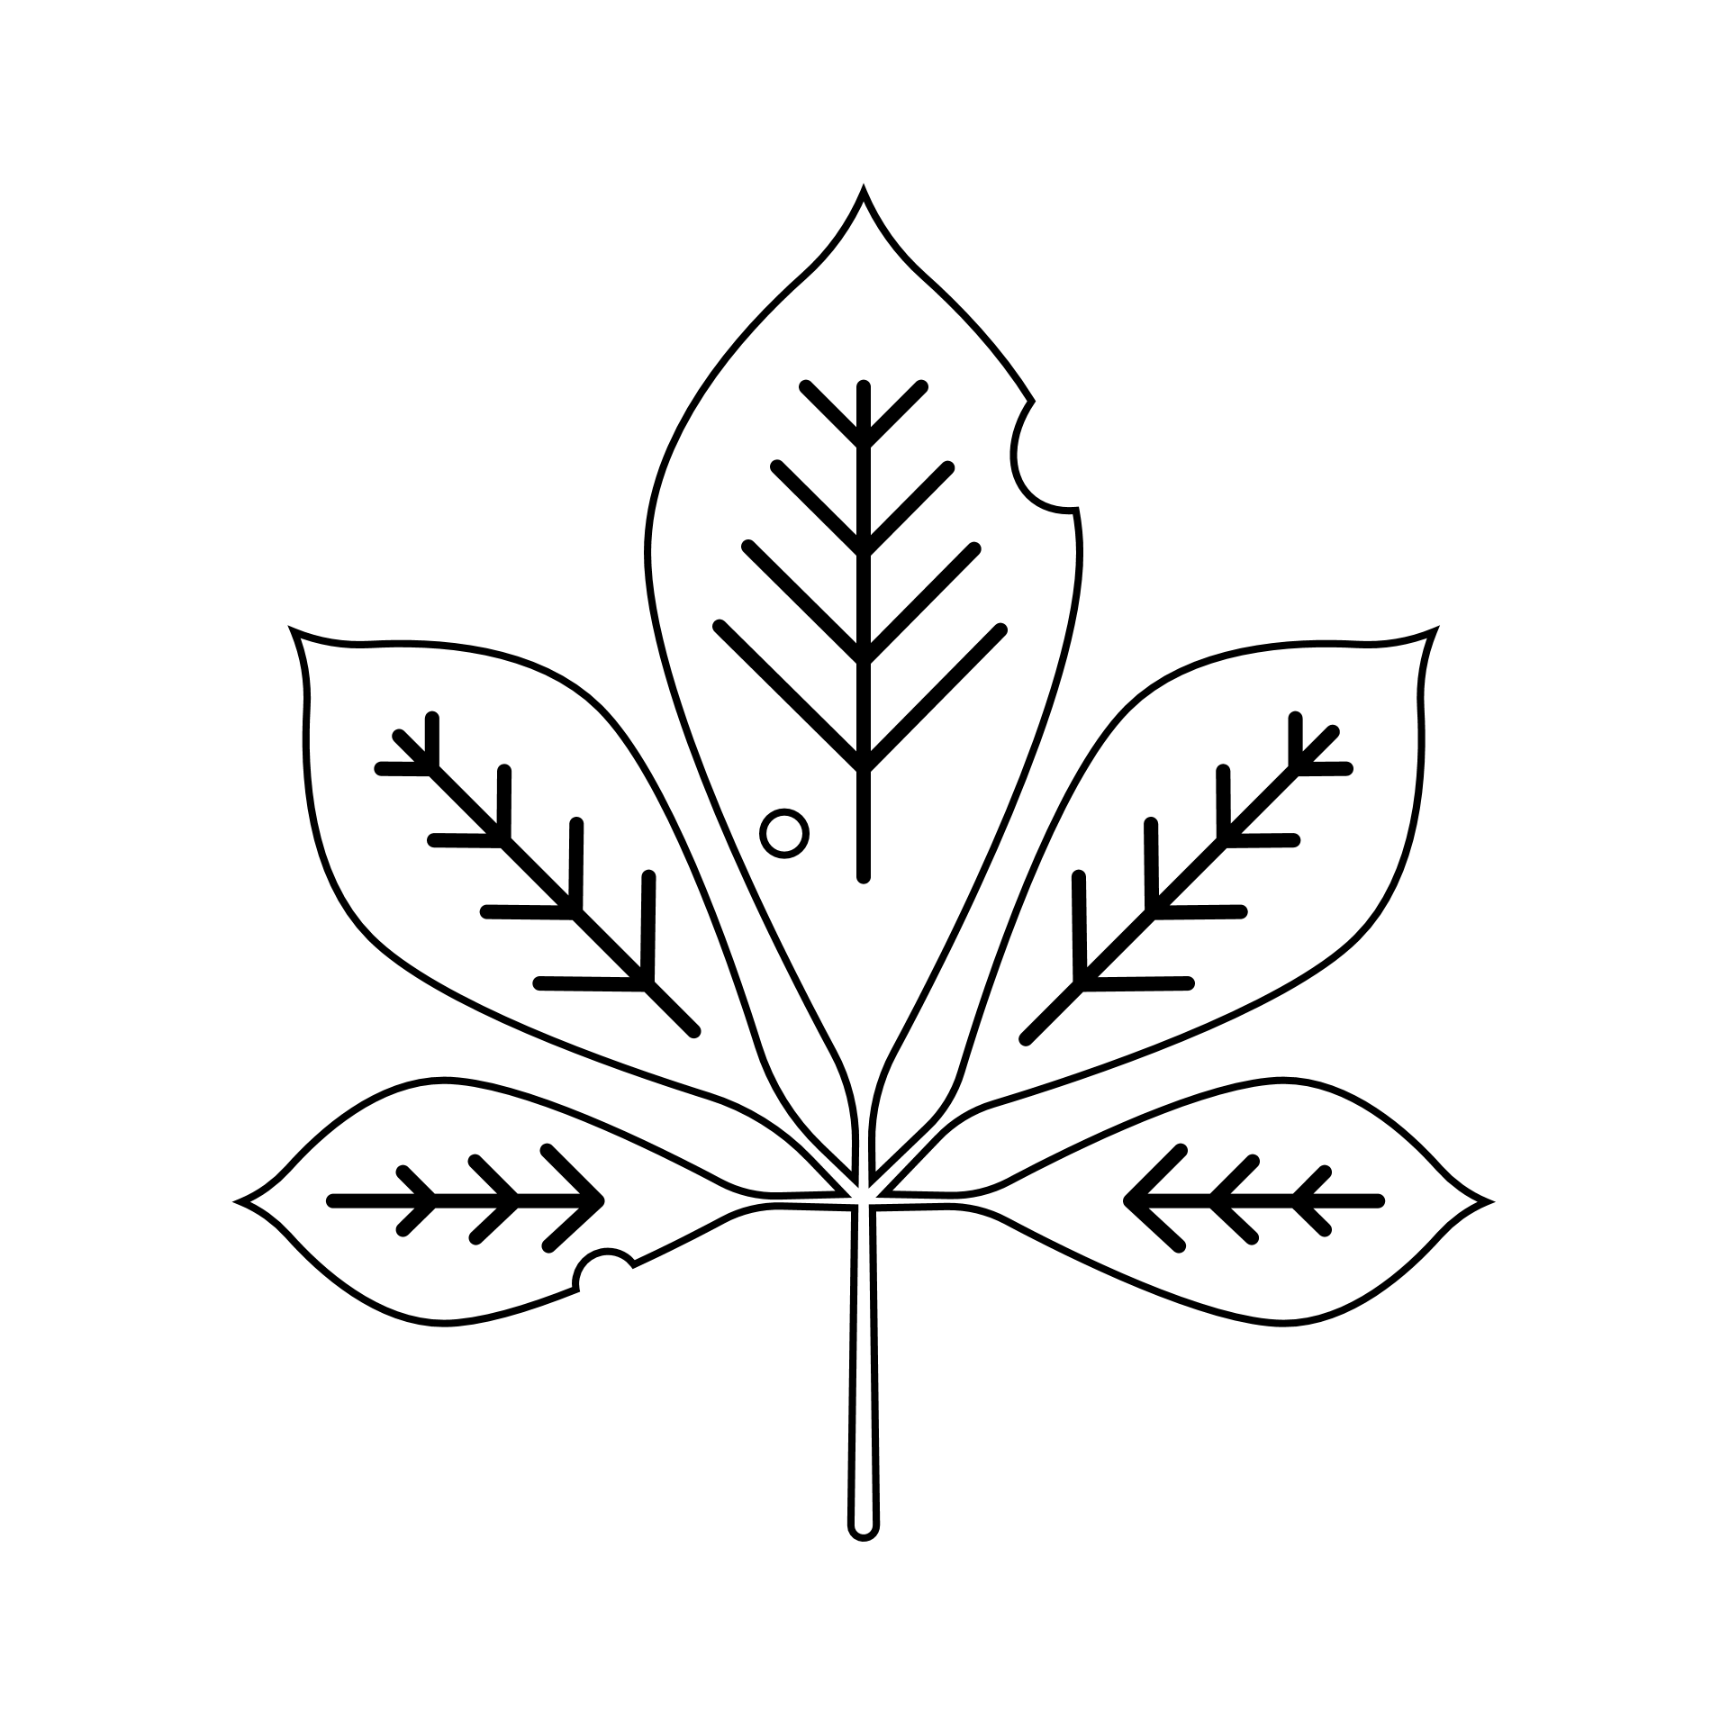 | A brown leaf
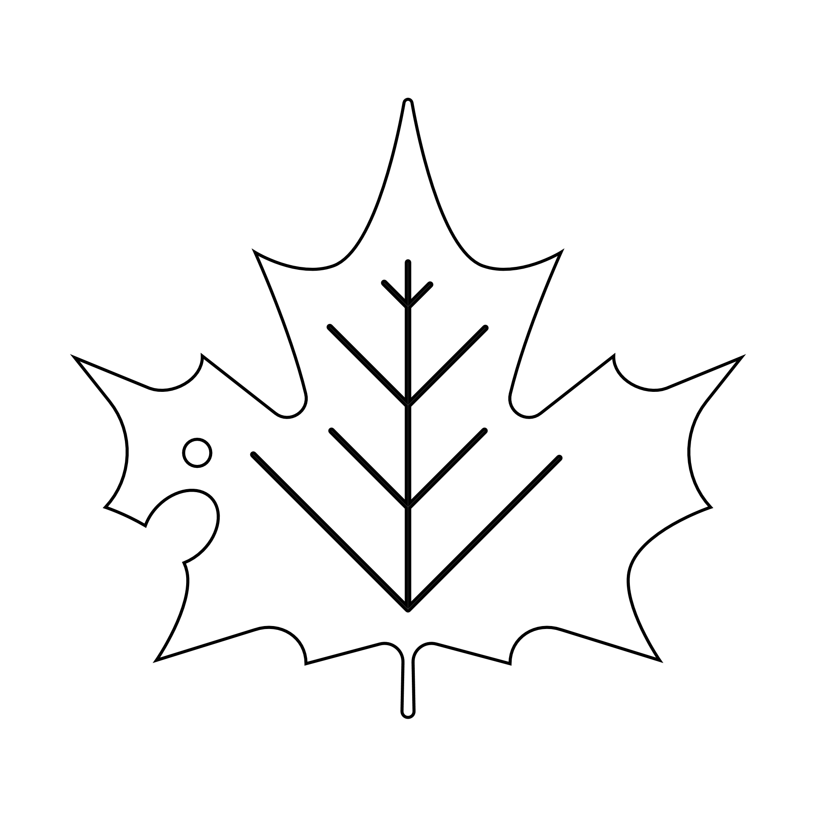 | Two leaves that look the same | Free Space | A leaf with two colors | A leaf with teeth
A leaf that’s still green | 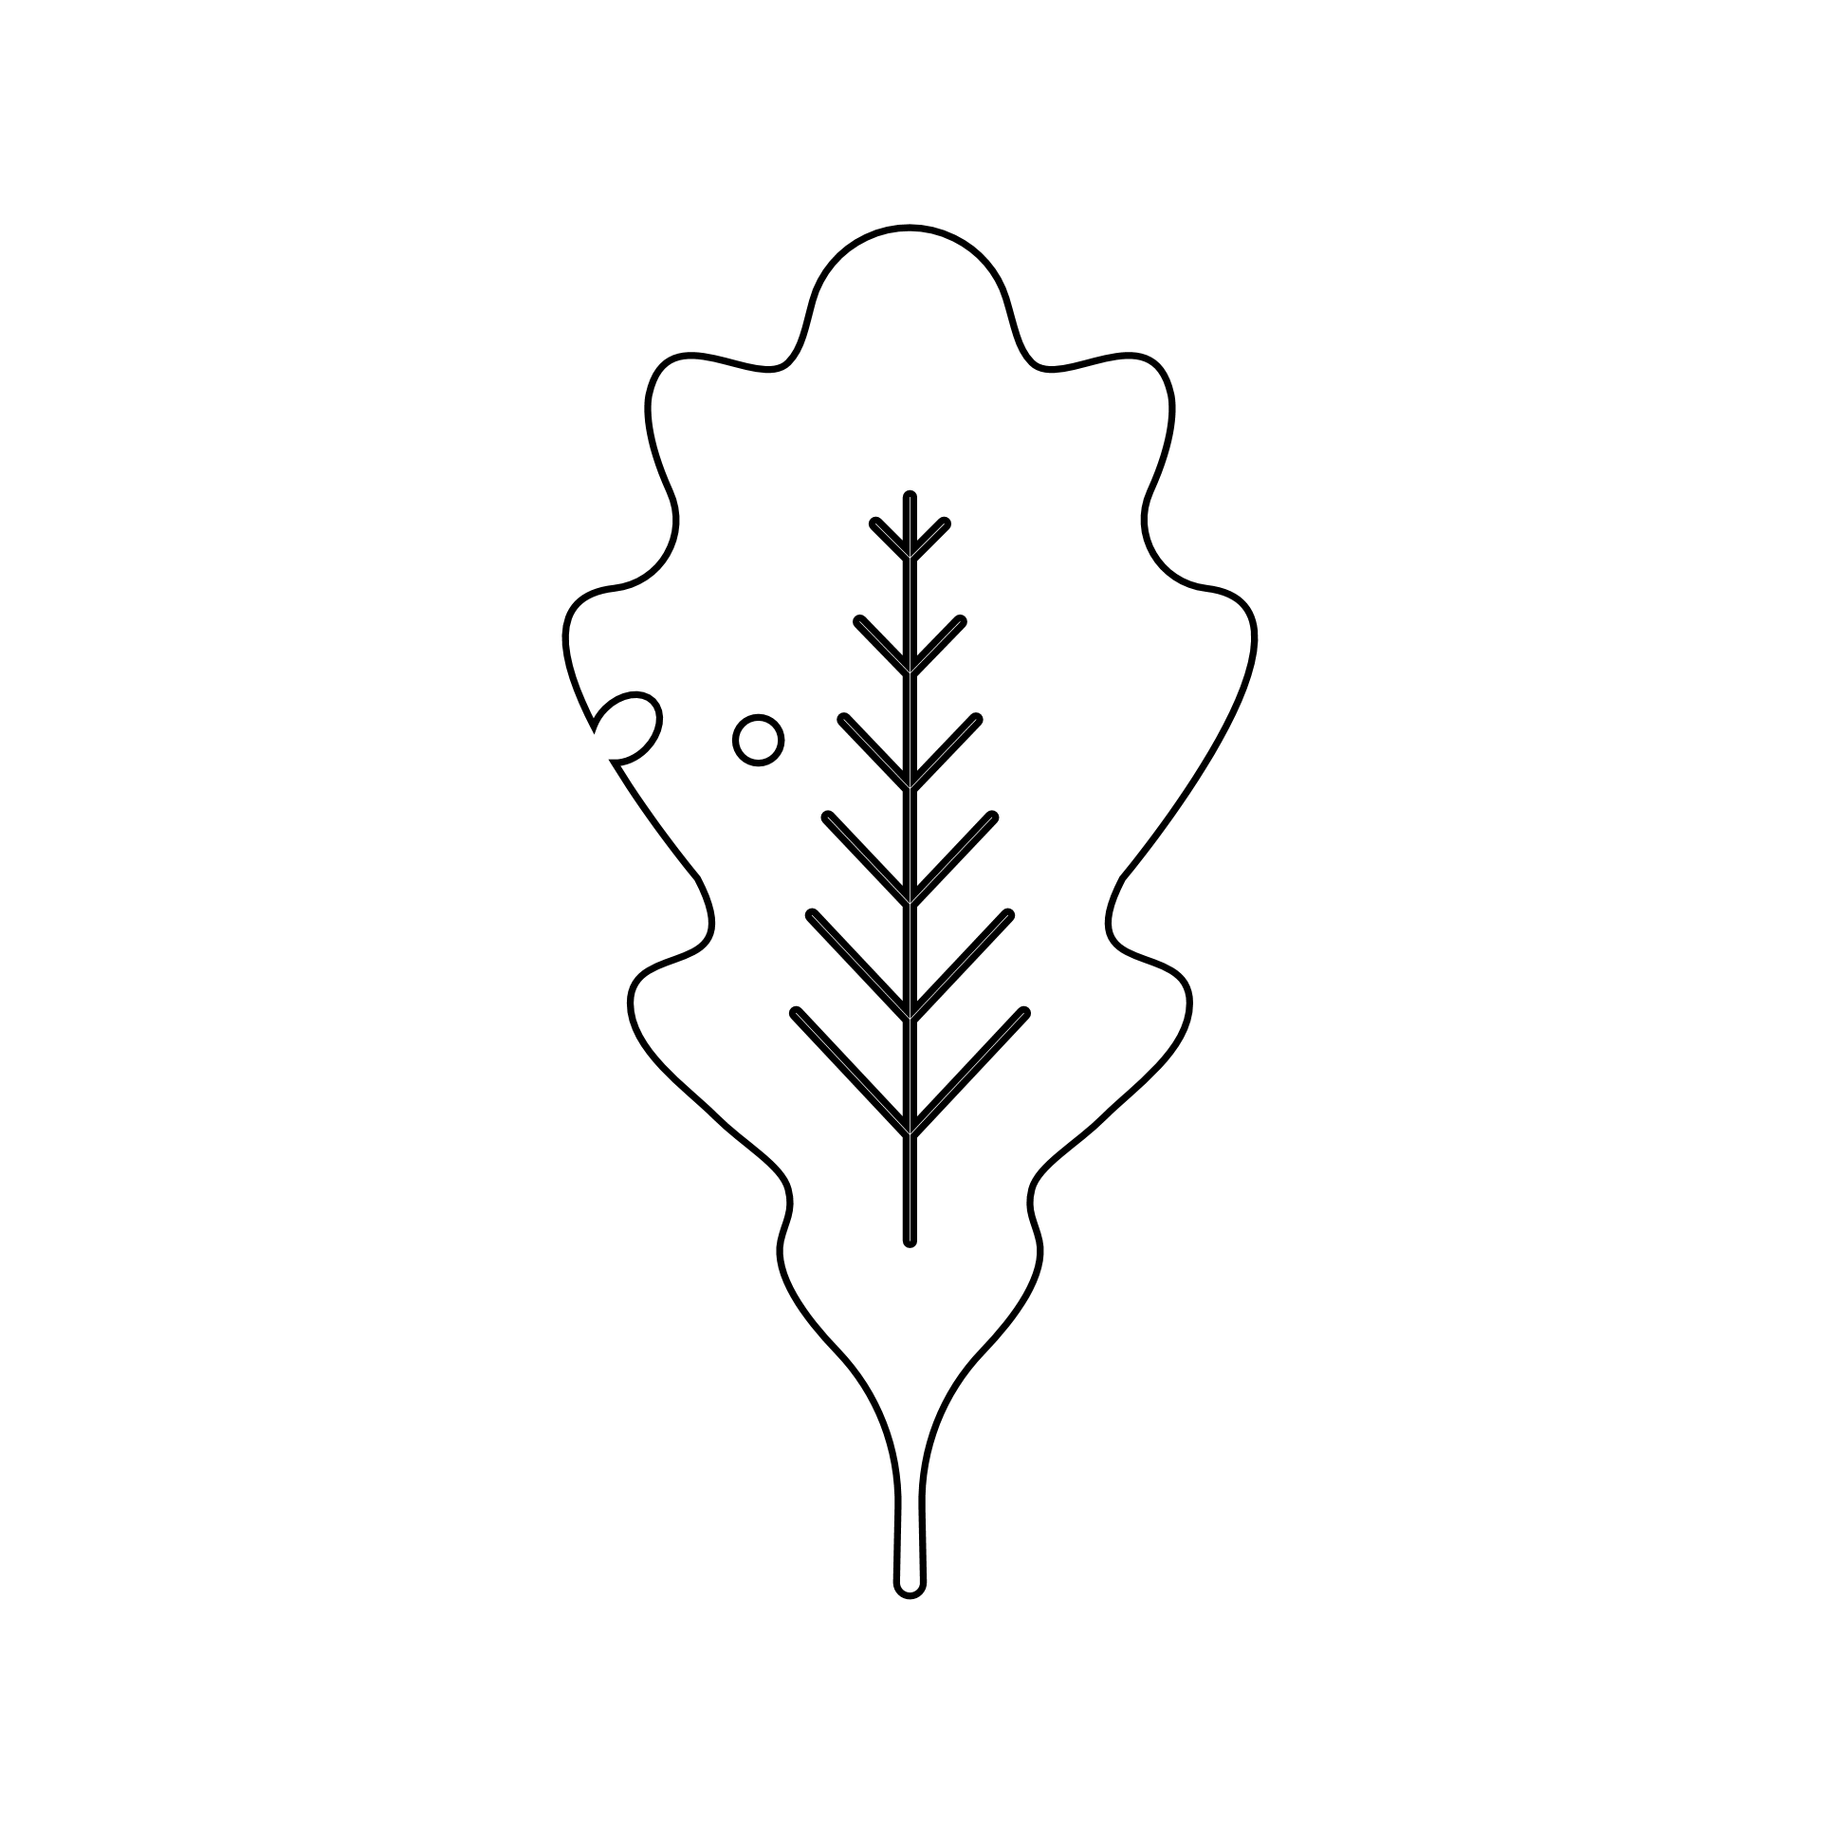 | A leaf that’s wider than your hand | A leaf with four colors | A wet leaf
A leaf with holes in the middle | A leaf that’s longer than your hand | 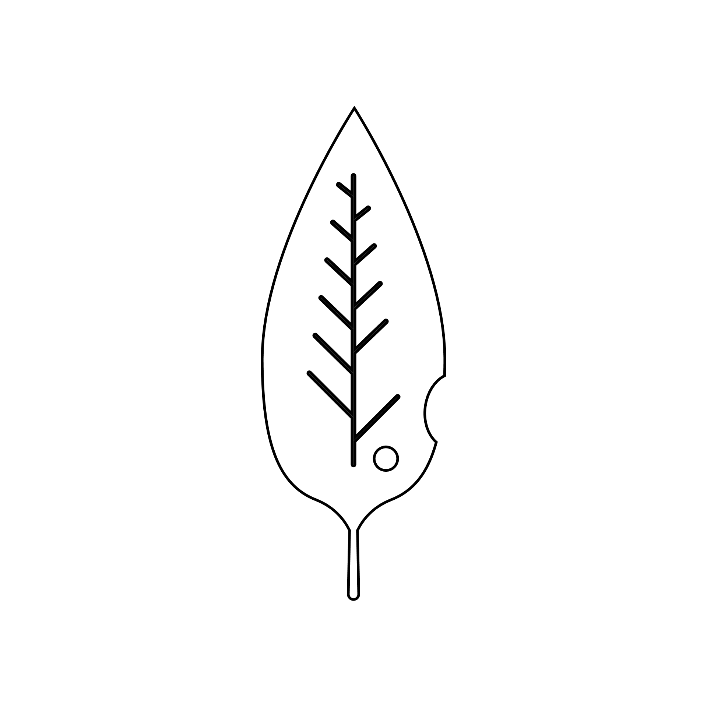 | A super dry leaf | An orange leaf

LEAF BINGO
A leaf with three colors | A leaf with a bug on it | A yellow leaf | A leaf with pointy tips | A leaf with three lobes
A leaf with round tips | A red leaf | A leaf with spots on it |  | A brown leaf
 | Two leaves that look the same | Free Space | A leaf with two colors | A leaf with teeth
A leaf that’s still green |  | A leaf that’s wider than your hand | A leaf with four colors | A wet leaf
A leaf with holes in the middle | A leaf that’s longer than your hand |  | A super dry leaf | An orange leaf

